The CHIME Team

CHIME (CHimeric IMmune Editing) is a CRISPR-Cas9 based delivery system that enables knockout of genes in diverse immune lineages without changing their development or function. Our goal is to use this powerful system to identify and validate regulators of responses and resistance to antitumor immunity mediated by TME-associated immune lineages. We believe this will allow the discovery and mechanistic dissection of targets that synergize with immune checkpoint blockade. In addition to target identification, we are also building new in vivo perturbation technologies to enable mechanistic dissection of novel targets using CRISPR.

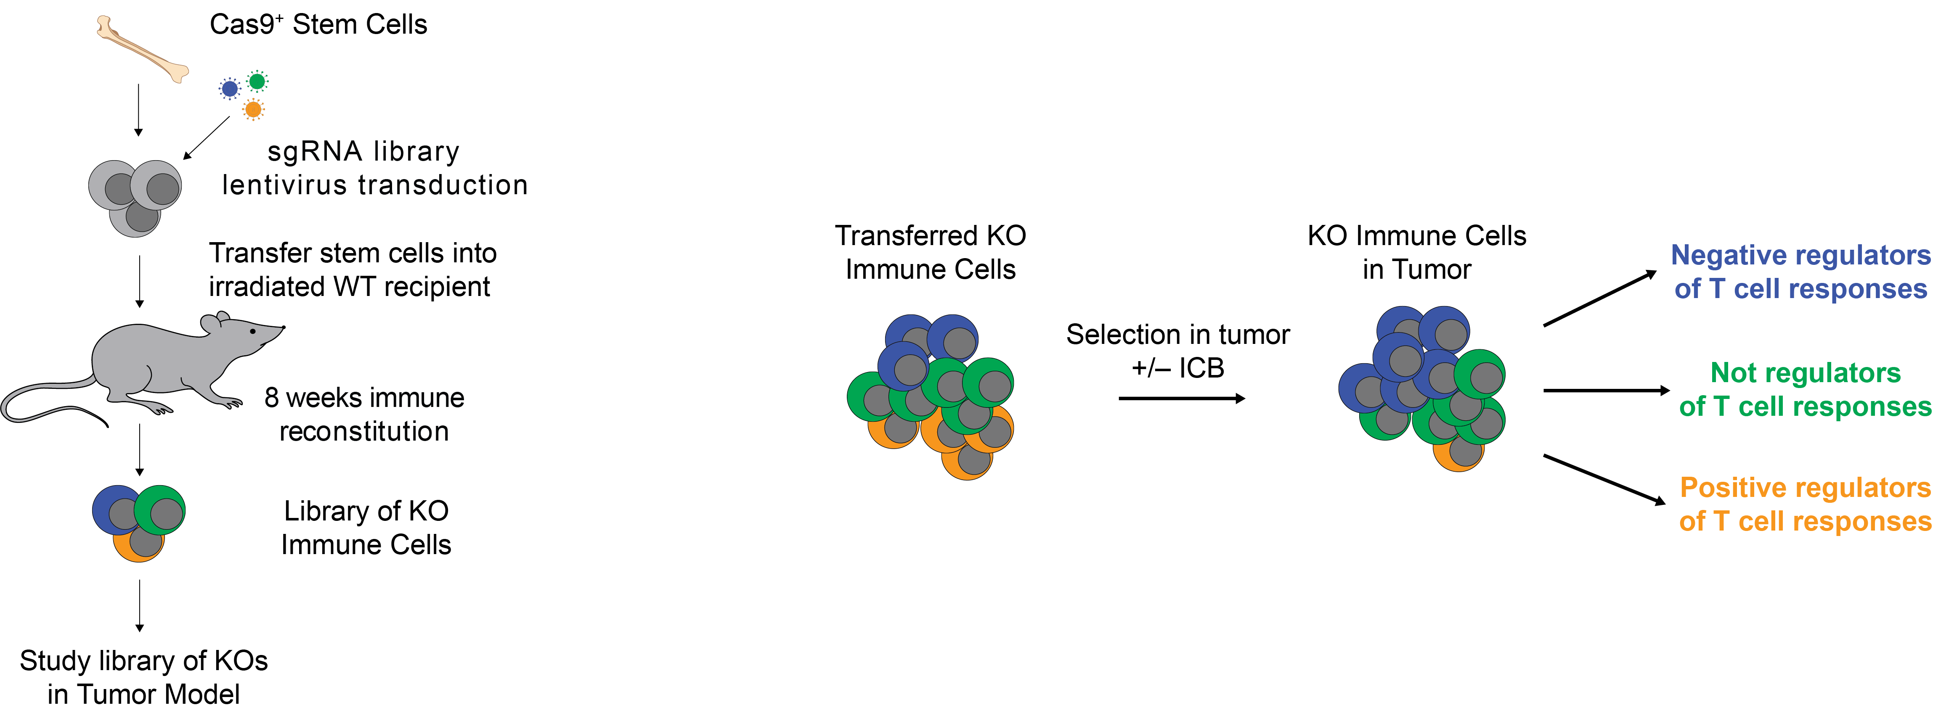



Publications

LaFleur, M.W., Nguyen, T.H., Coxe, M.A., Yates, K.B., Miller, B.C., Gillis, J.E., Sen, D.R., Gaudiano, E.F., Abosy, R.A., Freeman, G.J., Haining, W.N.*, and Sharpe, A.H.* PTPN2 regulates the generation of exhausted CD8⁺ T cell subpopulations and restrains tumor immunity. Nature Immunology 2019;20: 1335-1347. PMID: 31527834

LaFleur, M.W., Nguyen, T.H., Coxe, M.A., Yates, K.B., Trombley, J.D., Weiss, S.A., Brown, F.D., Gillis, J.E., Coxe, D.J., Doench, J.G., Haining, W.N.*, and Sharpe, A.H.* A CRISPR-Cas9 delivery system for in vivo screening of genes in the immune system. Nature Communications 2019;10(1): 1668. PMID: 30971695

